FESTSCHRIFT IN HONOR OF DR. VICTOR SIDEL

An interview with Dr. Vic Sidel

Clyde Lanford (Lanny) Smith MD, MPH, DTM&H; Linnea Capps, MD, MPH

Editor’s Note

Victor W. Sidel, MD, a long-time member of the faculty of the Albert Einstein College of Medicine and Montefiore Medical Center passed away on January 30, 2018. He was 86 years old. Dr, Sidel had dual appointments in Family and Social Medicine and Epidemiology and Population Health. He was pre-deceased by his wife, Ruth.
This interview was published in October of 2013 as part of a Festschrift devoted to Vic’s life and work. It explores several aspects of his long career, concentrating on activism and social justice issues. The transcript is based on two interviews. One was conducted by Lanny Smith, MD, MPH, DTM&H, and the other by Linnea Capps, MD, MPH. The final transcript was edited by Drs. Victor Sidel, Ruth Sidel, and Matthew Anderson.

Drs. Capps and Smith: Please tell us something about your origins. What are the seeds of your extraordinary, inspiring, and ongoing career promoting health and social justice?

Dr. Sidel: My parents arrived at Ellis Island as teenagers early in the 1900s. They came from different parts of the Ukraine, fleeing the pogroms that threatened the Jews of Eastern Europe. They quickly learned English, met each other, and married in Philadelphia. They both went to pharmacy school and opened a pharmacy in a very poor neighborhood in Trenton, New Jersey. Most of the neighborhood’s residents were black. I grew up working in the pharmacy and seeing a lot of both poor health and poverty.
Our household was bilingual; both Yiddish and English were spoken. My mother and father were Socialists. My father told me stories about the lectures he gave and how they varied depending upon the audience. When talking to general audiences he would have to remember to use “Ladies and Gentlemen” as an introduction. However, when speaking to labor unions he would begin with “Fellow Workers.” And when speaking to people on the far left, he would need to start with “Comrades.” I spent my summers at a left-leaning camp called Camp Kinderland where both Yiddish and English were spoken, where Sacco and Vanzetti were mourned, and where Paul Robeson came to sing and speak.

Clyde Lanford (Lanny) Smith, MD, MPH, DTM&H
Division of General Medicine and Primary Care
Department of Medicine
Beth Israel Deaconess Medical Center;
Global Community Health Advisor
Instructor of Medicine
Harvard Medical School;
Adjunct Associate Professor of Medicine
Departments of Internal Medicine and Family & Social Medicine
Montefiore Medical Center
Albert Einstein College of Medicine;
Founder and Liberation Medicine Counsel
Doctors for Global Health

Linnea Capps, MD, MPH
Co-Director of the Primary Care and Social Internal Medicine Residency Program
Department of Medicine
Montefiore Medical Center
Albert Einstein College of Medicine

There were five junior high schools in Trenton. In one of them the students were all black and the other four were all white. Graduates went on to Trenton Central High School, which had a class size of 3000. My main recollection of high school was graduation. Of the class of 3000 there were 10 graduates with perfect A grades, all of them white, and all of whom were the keynote speakers. We were each assigned a topic; mine was “housing.” In my speech I talked about a $10,000 home, which in 1949 was an impossible dream. Several realtors, having heard about the speech, asked that my diploma be withheld because I was obviously a “Communist.” I received my high school diploma nevertheless.
I went to Princeton, where I majored in Physics. My scholarship required me to hold a job, and I earned money by preparing the laboratories for the physics classes. The professor in Physics 101, “Physics for Non-Science Majors,” Eric Rogers, was a wonderful showman. One Saturday morning Professor Rogers asked me to to help in one of his famous demonstrations. He used a large washtub with a hole cut into the bottom and a rubber membrane fitted over the hole. The tub was hoisted 10 feet above ground, and my job was to hand Professor Rogers buckets of water while he stood on a stepladder pouring the water into the tub. The water collected in the center of the membrane, forming a perfect droplet. When the membrane finally burst, a perfectly circular hole was left. This was done to demonstrate surface tension. One particular Saturday morning, a special visitor was in attendance: Albert Einstein. Einstein was very grateful for the demonstration and thanked both Professor Rogers and me. He was of course an expert on surface tension. So I got to shake hands with Albert Einstein and have not washed my hands since!
From Princeton I went to Harvard Medical School, where I worked in the Biophysical Laboratory, studying the membrane structure of red blood cells. By the way, this later led the FBI to question me about my involvement with “red cells” as a subversive activity during medical school.
The work in biophysics was an important factor in my acceptance into the residency program in Internal Medicine at what was then called the Peter Bent Brigham Hospital. After the first year of residency, I applied to the U.S. Public Health Service for a commission, since this was a way of avoiding the “doctor draft” into military service then in effect because of the Korean War. I was accepted and assigned to the National Institutes of Health in Bethesda, again because of my work on the physiology of red blood cells.

Drs. Capps and Smith: Tell us about your work in Bethesda and how you wrote articles about the psychiatrist who voluntarily breached patient confidentiality. These articles attracted the attention of Bernard Lown, and your work together led to the Nobel Peace Prize 20 years later. This is a theme in your life: how one’s actions lead to further opportunities for action.

Dr. Sidel: While I was in Bethesda, a psychiatrist testified before a Congressional Committee about the confidential information given to him about the homosexual relationship between two code clerks at the National Security Agency after these two men fled to the Soviet Union. A number of the doctors at the National Institutes of Health protested the action of the psychiatrist and asked the Medical and Chirurgical Society of Maryland to sanction him for breach of confidentiality. The Society refused to do this, saying that the action was proper for the protection of national security. I wrote articles for The Nation¹ and The New England Journal of Medicine² discussing this case. These articles came to the attention of Bernard Lown, a well-known cardiologist at Harvard, who contacted me and asked me, on my return to Boston, to join an antiwar group he was organizing,
I returned to the Brigham to complete my residency in Internal Medicine and joined Lown’s group, which was to become Physicians for Social Responsibility (PSR). I consulted with Dr. David Rutstein, the Chair of Preventive Medicine at Harvard Medical School, and told him, “The practice of internal medicine is not what I want to do in my life. I want to prevent the wounds, not simply treat them.” Rutstein offered me the opportunity to lead a new Preventive Medicine Unit at Massachusetts General Hospital (MGH). I told Rutstein that I knew little about Preventive Medicine, and I was told, “You have a good reputation in internal medicine. MGH will hire you on that basis.”
Working with the Department of Medicine at MGH, Rutstein arranged two fellowships for me. They provided the opportunity for me to take the course offered for Epidemic Intelligence Officers at the Centers for Disease Control (now the Centers for Disease Control and Prevention), to teach courses at the Harvard School of Public Health, and to spend a year with Professor Margot Jefferies in London interviewing all of the General Practitioners in the London Borough of Camden.³
When I returned to the MGH, I learned that a position was open in the Department of Social Medicine at Montefiore Medical Center. I applied for the position and was interviewed by Dr. Martin Cherkasky. Cherkasky had founded the Department in 1950 shortly before being appointed Director of Montefiore. George Silver had been the second Chair of the Department until he resigned in 1966 to move to Washington to work on health services at the Office of Economic Opportunity created by the Johnson Administration. I was invited to be the third Chair of the Department of Social Medicine in 1969.
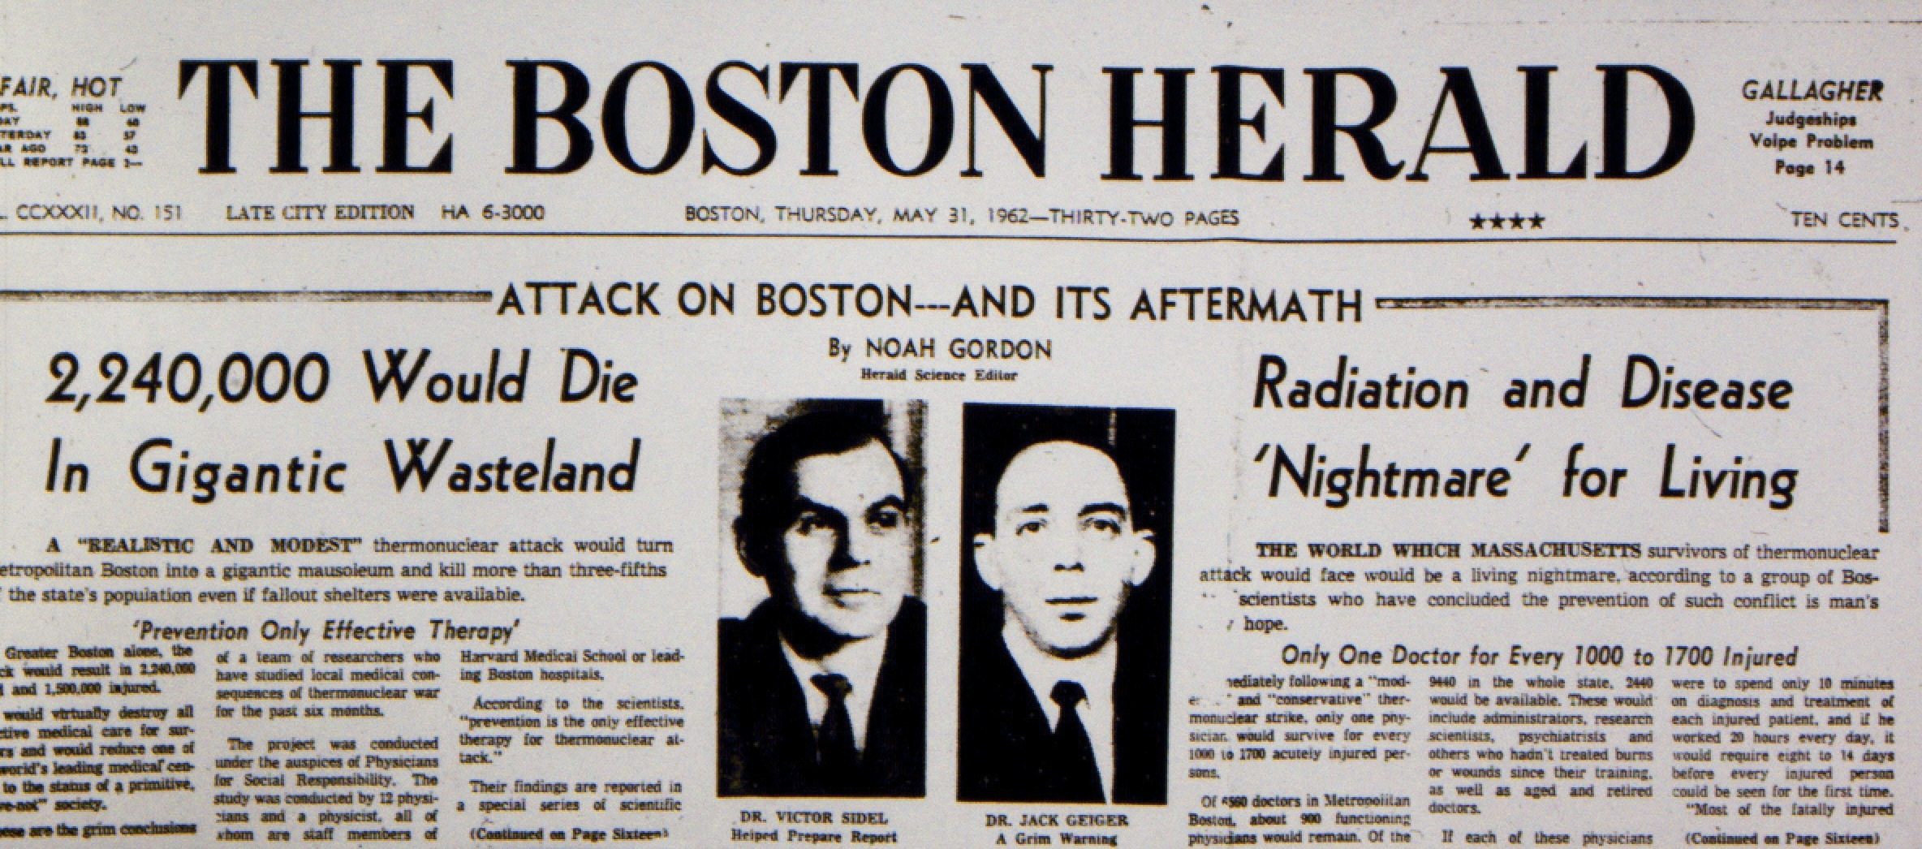

May 31, 1962 Boston Herald front page with photos of Victor Sidel and Jack Geiger, reporting on PSR study of medical effects thermonuclear war published in New England Journal of Medicine.

Drs. Capps and Smith: You have been in a leadership position of several major social justice organizations, including the International Physicians for the Prevention of Nuclear War, Physicians for Social Responsibility, Physicians for a National Heath Program, and the American Public Health Association. Could you tell us why you chose to serve in these groups? You have also taken positions that are not necessarily the norm among our physician peers. How did you choose your issues?

Dr. Sidel: I was interested in the work of PSR because of my previous work in physics. So when Bernard Lown invited me to join the group at a meeting in his home in a suburb of Boston, I accepted. I worked on the first publication of the new group, which we named Physicians for Social Responsibility. Lown, Jack Geiger (who was at that time a medical resident like me), and I wrote one of the articles in a series titled “Medical Consequences of Thermonuclear War.”⁴ We noted that a thermonuclear bomb could be up to 1,000-fold greater in its destructive power than the bombs dropped by the United States on Hiroshima and Nagasaki. These articles were published in The New England Journal of Medicine. The publication of these articles led to the formation of PSR chapters across the nation. The Pentagon ordered 1,000 copies of the issue in which the articles appeared and distributed them to U.S. military bases around the world.
In 1980, Bernard Lown, together with Yevgeniy Chazov, a Soviet cardiologist, founded the International Physicians for the Prevention of Nuclear War (IPPNW). In 1985, Lown and Chazov accepted the Nobel Peace prize on behalf of IPPNW. I was privileged to succeed Lown as a Co-President of IPPNW.
My involvement with APHA began at MGH when I joined the Massachusetts Public Health Association. When I moved to New York I joined the Public Health Association of New York City (PHANYC), which led to my work with its national organization, the American Public Health Association (APHA). I was elected President of APHA in 1985. In 1986, the APHA Annual Meeting was held in in Las Vegas, Nevada. We decided to hold a demonstration at the nuclear test site just outside Las Vegas. Some 300 people marched on the nuclear test site. The police, whom we had notified of our plans, arrested us as we marched over the line into the test site. We were arrested and charged with trespass, but the case against us was later dropped.
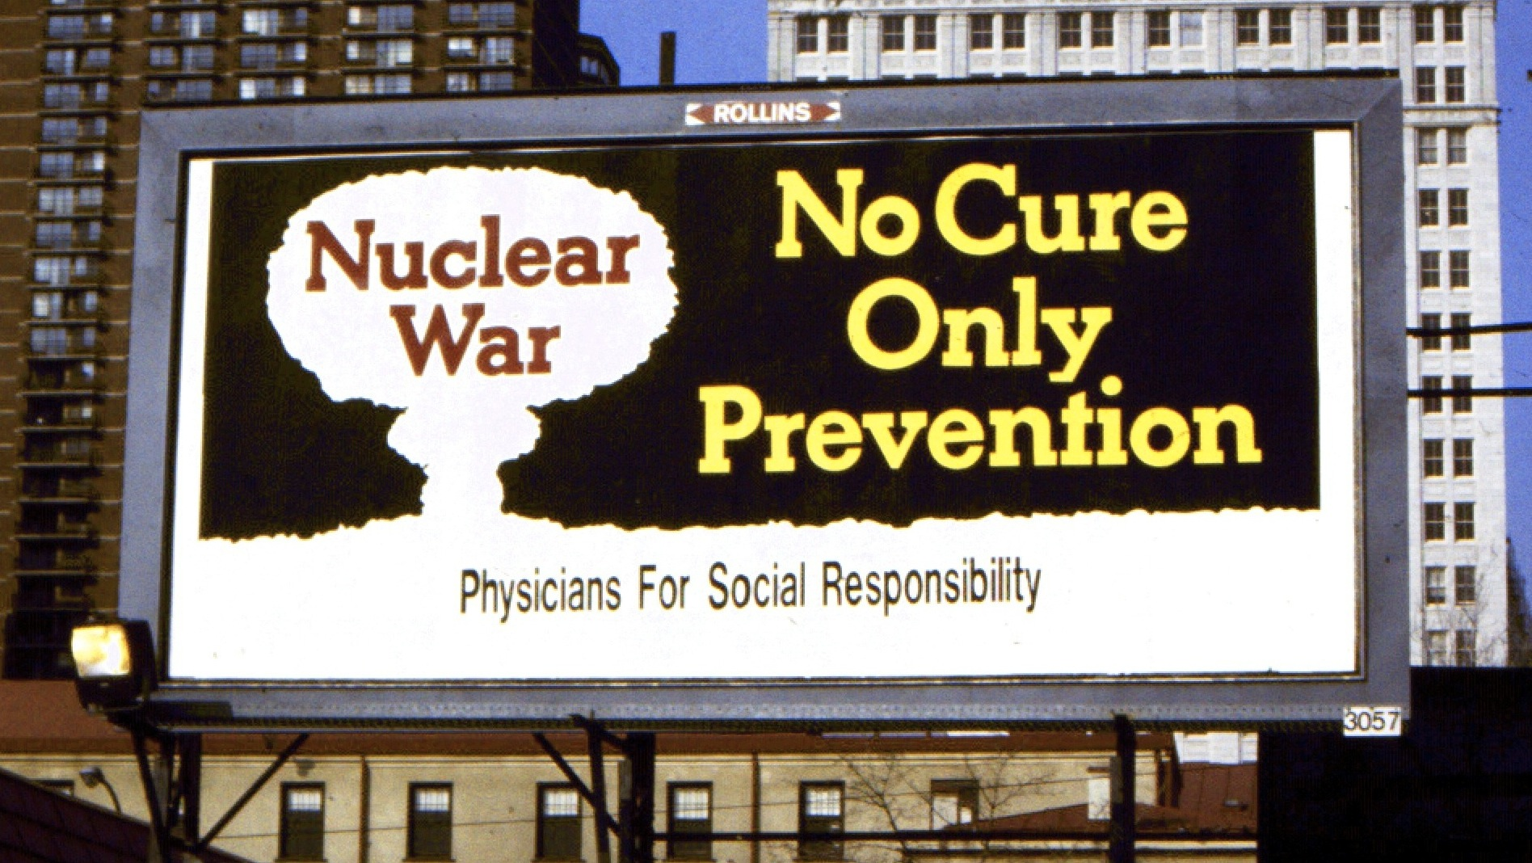

PSR billboard in Philadelphia in the early 1980s. Sponsored by Philadelphia PSR.
That was my first arrest. My second arrest, which also occurred while I was attending an APHA Annual Meeting, occurred in front of the South African Embassy in Washington, DC. Other APHA members and I marched in an effort to end the apartheid policies in South Africa.

Drs. Capps and Smith: Can you tell us how you and your wife Ruth came to work in China? And about your experiences in Chile?

Dr. Sidel: I had worked with Arthur Galston, a professor of biology at Yale, in studies on the effects of herbicides and the use of Agent Orange on the foliage that was providing hiding spaces for the Viet Cong. While Galston was in Vietnam, the U.S. ping-pong team was invited to play in China. There had been no formal U.S. visits to China since 1949, the date of the “liberation of China.” Galston went to the Chinese Consulate in Hanoi and asked to be admitted into China. On the day he was to leave, he received a visa to enter China.
When Galston returned to the United States, I phoned and asked him if he could help get me invited to visit China in view of our past work in Vietnam. Galston wrote to the head of the Chinese Academy of Medical Sciences and asked permission for my wife and me to visit China. Three months later, Galston phoned and told us that we had just been invited to China. My older son and I went to the Chinese Embassy in Ottawa to pick up the visas. Our group during the visit turned out to be a delegation of four physicians and “their wives.” So much for the new non-sexist China! The three other invited physicians were Paul Dudley White, a famous Boston cardiologist; Grey Diamond, another cardiologist; and Sam Rosen, an otolaryngologist from Mount Sinai Hospital in New York.
The program that was prepared for the delegation addressed access to medical care, and I requested a focus on rural medical care and the role of Barefoot Doctors. Ruth requested information on issues related to the role of women and the care of children. Sure enough, every place we went they took her to speak with relevant people in authority and to visit the relevant institutions. When we returned, Ruth wrote a book titled Women and Child Care in China: A Firsthand Report.⁵ We have since been back several times, including a memorable visit with our two teenaged sons. China has changed dramatically over the years, but back in 1971–1972 it was a place where the Communist Party under Mao Zedong’s leadership was developing the use of non-traditional medical workers in order to serve the vast Chinese population, particularly in rural areas. “Serve the People” was the rallying cry of the time and was the title of the book on health care we wrote on our return.⁶ This model proved to be extraordinarily relevant to medical care in other developing countries, and the World Health Organization sponsored several conferences and published several books on the topic.
In 1973, Dr. Roberto Belmar invited Ruth and me to Chile to observe the major changes in health services under President Salvador Allende. Allende, a physician, organized health services according to new socialist principles. During the military coup in September 1973, two months after our visit, Allende perished, many were tortured, and Chile was taken over by a repressive military government under General Augusto Pinochet. Dr. Belmar sent me a message asking for help in getting out of the country. Martin Cherkasky immediately found the funds to bring Roberto out of Chile, and he became a valued member of the Department of Social Medicine. With the leadership and inspiration of Dr. Belmar, Ruth and I—together with many others—organized the Emergency Committee to Save Chilean Health Workers.

Drs. Capps and Smith: Could you tell us something the history of Montefiore and its connections with movements for social justice?

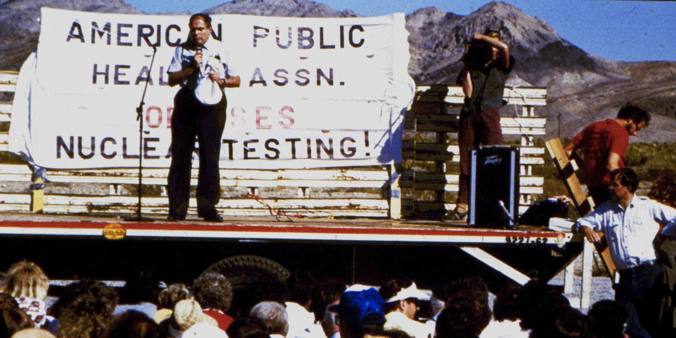

Victor Sidel speaking at APHA nuclear test protest in Nevada, 1986. Carl Sagan is seen standing to the right of the stage.

Dr. Sidel: From its very beginning, Montefiore had a history of caring for poor people. It began as a hospital for chronic diseases; actually it was for “incurable illnesses,” as its first name indicated. If anyone wants to really understand Montefiore’s history, there is a wonderful book written by Dorothy Levenson on the history of Montefiore.⁷ The book discusses the way in which Montefiore evolved from a chronic diseases hospital to a major teaching hospital.
During my period as Chair of Social Medicine, I had the privilege of working with Roberto Belmar, Ernest Drucker, Nancy Dubler, Pyser Edelsack, Sally Kohn, David Michaels, Steve Safyer, Peter Selwyn, and Gladys Valdivieso, among others. We shared a common mission of social justice, and it was a genuine privilege working with such an inspired and committed group of people. After I stepped down as Chair in 1985 when I became president of APHA, Michael Alderman became Chair and added the term “Epidemiology” to the title of the department. When Alderman stepped down in 2000, Tom Rohan took over as Chair, and changed “Social Medicine” to “Population Health,” creating the current Department of Epidemiology and Population Health. Peter Selwyn and Hal Strelnick added “Social Medicine” to the title of the Department of Family Medicine and continued the tradition of social activism.

Drs. Capps and Smith: Another question about your career as a writer: you have written many articles, books on a wide variety of subjects. Can you share with us how that came about? Do you have any thoughts about your own personal method of writing and collaborating with others and any advice you would give to younger people who want to do research and write?

Dr. Sidel: My advice is to find a good co-author and collaborate. Some of these articles were written alone, but those were nowhere near the kind of fun that one has by working with someone. The article that I have been working on most recently is co-authored by Barry Levy, who is a professor at Tufts in Boston. We have collaborated on War and Public Health,⁸ Terrorism and Public Health,⁹ and Social Injustice and Public Health¹⁰; all of these are edited books and have multiple contributors.
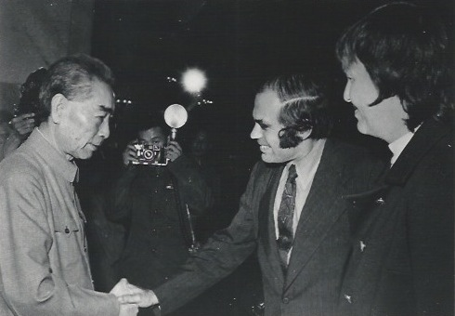

Vic and Ruth Sidel meet Zhou Enlai, Premier of the People’s Republic of China, at the Great Hall of the People in Beijing, 1971.
The question is, how do you keep on writing? Do other things as well. One big mistake I made in my career was that at the MGH I gave up internal medicine (which I was trained in) and stopped seeing patients. If I had to do it all over again, 1 would try to maintain a practice while doing these other things. This is of course not possible, but that is still a regret.

Drs. Capps and Smith: Your work has a global perspective. Could you share with us something about this? Perhaps how you came to be the first MD to hold the Cleveringa Chair in Leiden?

Dr. Sidel: Rudolph Cleveringa was a Professor of Law and Dean of the Law School at the University of Leiden in the Netherlands. When the Nazis invaded, they demanded the law school fire all Jewish professors. Cleveringa said that he would resign as the Dean and was himself fired by the Nazis, who were by that time in control of the University. After Cleveringa resigned, he was imprisoned for a while, but eventually he was released and after the war he was again named Dean of the Law School. Since his death, the University has honored his memory through the creation of an annual Cleveringa Professorship.
I was the first non-lawyer do be invited to be a Cleveringa Professor, and I was asked if I would give the “inaugural lecture” for my year as Professor. The speaker speaks from a high loft in the main auditorium about a subject of his or her choice, and my choice was “Medicine and Human Rights.”¹¹ Following this, Ruth and I spent a year in the Netherlands teaching at the medical school. We had lots of discussion with Dutch students about the problems in the Netherlands, the problems in the United States, and possible ways of dealing with them. This led to further discussions about human rights all over the world.

Drs. Capps and Smith: Do you have any final words to say to young people who have chosen to be physicians about how they can go about leading ethical lives in their careers?
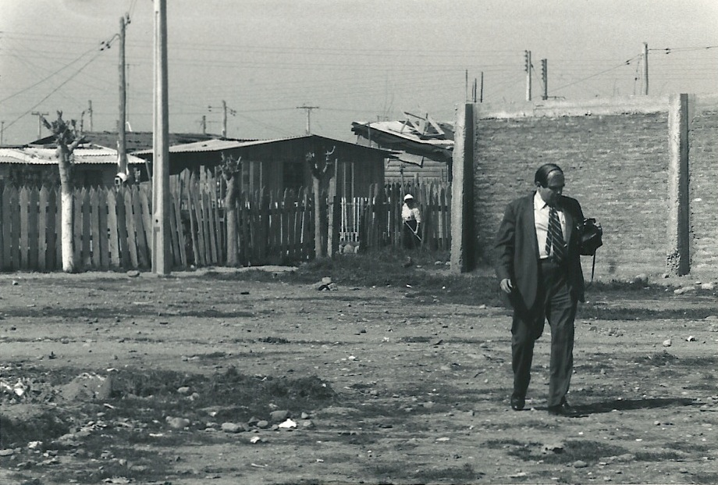

Dr. Sidel was invited to Chile in 1979 by the Catholic Church for a peaceful protest of the Chilean military government.

Dr. Sidel: First of all, don’t learn any lessons from me. I have had a wonderful life, but it is not one for anyone else. As I said, don’t give up clinical medicine; that’s a mistake. You will find that no matter how much you love what you are doing, you will miss contact with patients. My advice to young people is to follow your heart and to try to help people, and you can’t go wrong.

Drs. Capps and Smith: We would like to offer thanks for these wonderful stories.

References
- Dubler NN, Liebman CB. Bioethics mediation: a Sidel V. Medical ethics and the Cold War. Nation. 1960 Oct 29;191:325.
- Sidel VW. Confidential information and the physician. N Engl J Med. 1961;264(22):1133-7.
- Sidel VW, Jefferys M, Mansfield PJ. General practice in the London Borough of Camden. Report of an enquiry in 1968. J R Coll Gen Pract. 1972 Oct;22 Suppl 3:1-26 [cited 2013 Sep 30]. Available from: http://www.ncbi.nlm.nih.gov/pmc/articles/PMC2635217
- Sidel V, Geiger HJ, Lown B. The medical consequences of thermonuclear war. II. The physician's role in the post-attack period. N Engl J Med. 1962 May 31;266(22):1137-45.
- Sidel R. Women and child care in China: a firsthand report. New York: Hill and Wang; 1972.
- Sidel VW, Sidel R. Serve the people: observations on medicine in the People's Republic of China. New York: Josiah Macy; 1973.
- Levenson D. Montefiore: the hospital as social instrument, 1884–1984. New York: Farrar, Straus & Giroux; 1984.
- Levy BS, Sidel VW, editors. War and public health. 2nd ed. New York: Oxford University Press; 2008.
- Levy BS, Sidel VW, editors. Terrorism and public health: a balanced approach to strengthening systems and protecting people. 2nd ed. New York: Oxford University Press; 2012.
- Levy BS, Sidel VW, editors. Social injustice and public health. 2nd ed. Oxford: Oxford University Press; 2013.
- Sidel V, editor. Medicine and Human Rights. Cleveringa Inaugural Oration. Leiden,The Netherlands. November 26, 1998 [cited 2013 Sep 30]. Available from: https://openaccess.leidenuniv.nl/bitstream/handle/1887/5368/OR171.pdf?sequence=1

H. Jack Geiger, MD, MSciHyg, later started the first Office of Economic Opportunity (OEO) Community Health Centers, located in Mount Bayou, Mississippi, and Columbia Point, Boston, Massachusetts.

